**Enhanced phase sensitivity in DSU(1,1) interferometer via photon recycling**

Taj Kumar, Aviral Kumar Pandey, Anand Kumar, **Devendra Kumar Mishra\***

*Department of Physics,*

*Institute of Science, Banaras Hindu University,*

*Varanasi 221005, India*

*\*kndmishra@gmail.com*

**ABSTRACT**

In the SU(1,1) interferometer, proposed by Yurke [1], beam splitters are replaced by nonlinear elements like optical parametric amplifiers (OPA) to achieve the sensitivity up to the Heisenberg limit [2]. Non-Gaussian operations, like photon addition or subtraction, can further improve its phase sensitivity and robustness against photon loss but at a high implementation cost. To address this issue, Wei Ye *et. al* [3] introduced the displacement-assisted SU(1,1) (DSU(1,1)) interferometer, using a displacement operator with displacement strength |γ|.

In this work, we propose a novel method to improve the phase sensitivity of the DSU(1,1) interferometer through photon recycling [4]. We begin with a DSU(1,1) interferometer having a vacuum state at port "a" and a squeezed vacuum state (with squeezing parameter r) at port "b". We consider a phase shift ϕ, experienced in the arm "b". This setup is modified by re-injecting the output mode "a" into the input mode after a phase shift θ, and photon loss is characterized by $\sqrt{1-T}$, where T is the transmission coefficient of a fictitious beam splitter.

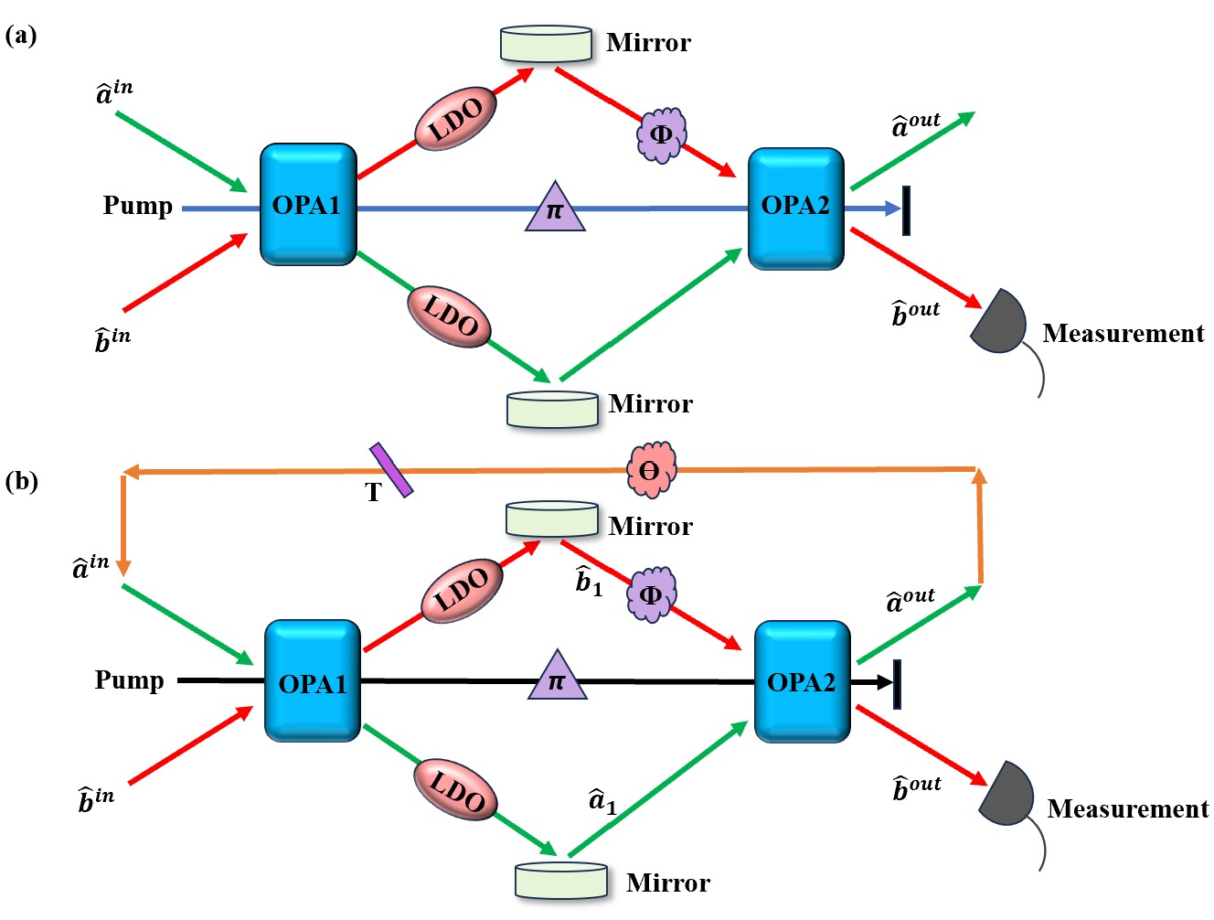

Fig.1. Scheme for phase estimation with photon recycling technique: (a) Schematic diagram of a DSU(1,1) interferometer with the output beam "a" disregarded. (b) The modified scheme with the output mode "a" re-injected into the input mode "a" (PR-DSU(1,1) interferometer).

We determined the phase sensitivity of the PR-DSU(1,1) interferometer, denoted as ${∆ϕ}^{PR}$ under two detection schemes: single-intensity detection (SID) and homodyne detection (HD). To provide the fundamental theoretical limit of phase sensitivity, we computed the corresponding quantum Cramér-Rao bound (QCRB), denoted as ${ ∆ϕ}_{QCRB}^{PR.}$. To assess the improvement in the performance of DSU(1,1) interferometer due to photon recycling, we compared the PR-DSU(1,1) interferometer with the conventional DSU(1,1) interferometer. For this comparison, we defined two enhancement factors $Σ= {∆ϕ}^{Conv.}/{∆ϕ}^{PR.}$ and $Ξ= { ∆ϕ}_{QCRB}^{Conv.}/{ ∆ϕ}_{QCRB}^{PR.}$. Additionally, for each detection scheme, we evaluated the improvement in the phase sensitivity of the PR-DSU(1,1) interferometer relative to the SNL using $Γ=$ $∆ϕ_{SNL} /{∆ϕ}^{PR}$ and similarly, the improvement in QCRB relative to the SNL using $Λ= ∆ϕ_{SNL} /{ ∆ϕ}_{QCRB}^{PR.}$.

Our results demonstrate that both Σ and Ξ can exceed unity, indicating that the PR-DSU(1,1) interferometer can achieve improved phase sensitivity and a lower QCRB compared to the conventional DSU(1,1) configuration. This clearly highlights the crucial role of photon recycling in enhancing interferometric sensitivity. We further analyzed Γ as a function of the phase shifts ϕ and θ, for various values of the T, g, ∣γ∣, and r, under both SID and HD detection schemes. The values of Γ exceeding unity indicate that our scheme can achieve phase sensitivity beyond the SNL. Moreover, it increases with an increase in T, g, |γ|, and r. Comparing the phase sensitivity of the PR-DSU(1,1) interferometer under both SID and HD schemes, we observe that the HD scheme outperforms the SID scheme. The HD scheme also exhibits a broader region of θ and $ϕ$ for enhanced phase sensitivity beyond SNL, further demonstrating its superiority over the SID scheme. Similarly, we plotted Λ as a function of r for different values of g and observed that Λ exceeds unity and increases monotonically with both g and r. Further, by plotting Λ as a function of T for various ∣γ∣, we observed significant enhancement due to photon recycling, especially in the presence of LDO, provided an appropriate combination of g, r, and photon loss in the feedback arm is chosen.

Therefore, our findings show that this modified scheme has phase sensitivity and QCRB beyond the SNL as well as beyond those in the case of conventional DSU(1,1) interferometer, offering a novel approach to increase phase sensitivity via photon recycling.

**References**

[1] Yurke, B., McCall, S. L., \& Klauder, J. R. (1986). SU (2) and SU (1, 1) interferometers. Physical Review A, 33(6), 4033.

[2] Ou, Z. Y., and Xiaoying Li. "Quantum SU (1, 1) interferometers: Basic principles and applications." APL Photonics 5.8 (2020).

[3] Ye, Wei, et al. "Quantum-improved phase estimation with a displacement-assisted SU (1, 1) interferometer." Optics Express 31.25 (2023): 41850-41863.

[4] Li, Dong, et al. "Enhanced phase sensitivity in a Mach-Zehnder interferometer via photon recycling." Optics Express 31.4 (2023): 6499-6513.